Figure 4.3. Examples of two HGT insertions used for ‘aging’ analysis. The right panel shows homology of each insertion and its 5 kb flanking regions across species: green denotes HGT inserts, blue flanking regions, with red and blue bands indicating forward and inverted homology (darker shades = higher similarity). The left phylogeny is based on Chapter 3; species lacking the insertion are shown as a dashed line. Red arrows indicate the inferred timing of HGT insertions.

Figure 4.4. Example of a chimeric HGT insertion from P. tryoni tegminifera. The top sequence is divided into seven segments, while the circular map below represents the source genome of Blattabacterium cuenoti (CP142624.1). Numbers below the insertion indicate the corresponding genomic positions, with yellow labels marking specific coordinates.

Table 4.1. Genome assembly statistics and quality metrics for ten Panesthiinae and Geoscapheinae species, including the tissue sources used for DNA extraction.
Species | ID | DNA extract tissue | Genome Size (Gb) | No. of contigs | N50 (Mb) | GC(%) | BUSCO complete (%) | Fragmented BUSCOs (%) | Missing BUSCOs (%) | Duplicated BUSCOs (%)
Panesthia lata | M01 | Leg muscle | 1.765 | 11181 | 1.142 | 35.83 | 97.7 | 1.6 | 0.7 | 0.6
Panesthia sloanei | Z01 | Leg muscle | 1.822 | 14705 | 1.667 | 35.85 | 98.6 | 0.6 | 0.8 | 1.5
Panesthia australis | Z02 | Leg muscle | 1.795 | 11533 | 1.344 | 35.90 | 97.9 | 1.2 | 0.9 | 1.2
Macropanesthia kraussiana | Z03 | Leg muscle | 1.795 | 9868 | 1.927 | 35.88 | 99.3 | 0.3 | 0.4 | 7.8
Macropanesthia lithgowae | Z04 | Leg muscle | 1.824 | 6815 | 1.438 | 35.88 | 98.2 | 1.0 | 0.8 | 2.0
Panesthia tryoni tryoni (Kroombit) | Z05 | Leg muscle | 1.716 | 13000 | 0.635 | 35.92 | 95.2 | 1.9 | 2.9 | 1.3
Parapanesthia gigantea | Z10 | Leg muscle + fat body | 1.845 | 4559 | 1.043 | 35.67 | 98.4 | 1.6 | 0.0 | 0.4
Panesthia tryoni tegminifera | Z11 | Leg muscle + fat body | 1.843 | 4277 | 1.188 | 35.76 | 98.8 | 0.4 | 0.8 | 0.8
Panesthia tryoni tryoni (Eungella) | Z12 | Leg muscle + fat body | 1.862 | 5156 | 0.862 | 35.77 | 96.9 | 2.4 | 0.8 | 1.2
Neogeoscapheus dahmsi | Z14 | Leg muscle + fat body | 1.899 | 2171 | 5.223 | 35.47 | 99.6 | 0.0 | 0.4 | 0.8

Supplementary material for Chapter 4

Figure S4.1. Five examples of chimeric inserts, illustrated using BLAST results. For each insert, the ten best BLAST hits are depicted, with the alignments of each fragment in the top hit.
Additional chimeric sequence 1:
Diploptera punctata JASPKZ010002709.1: 268362-269615 (1253 bp)
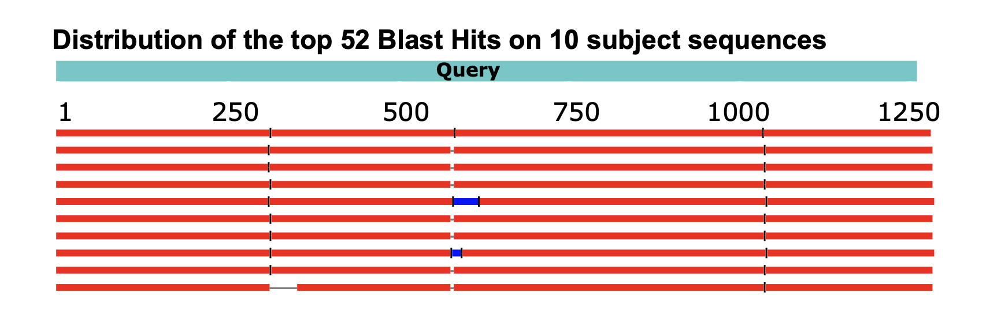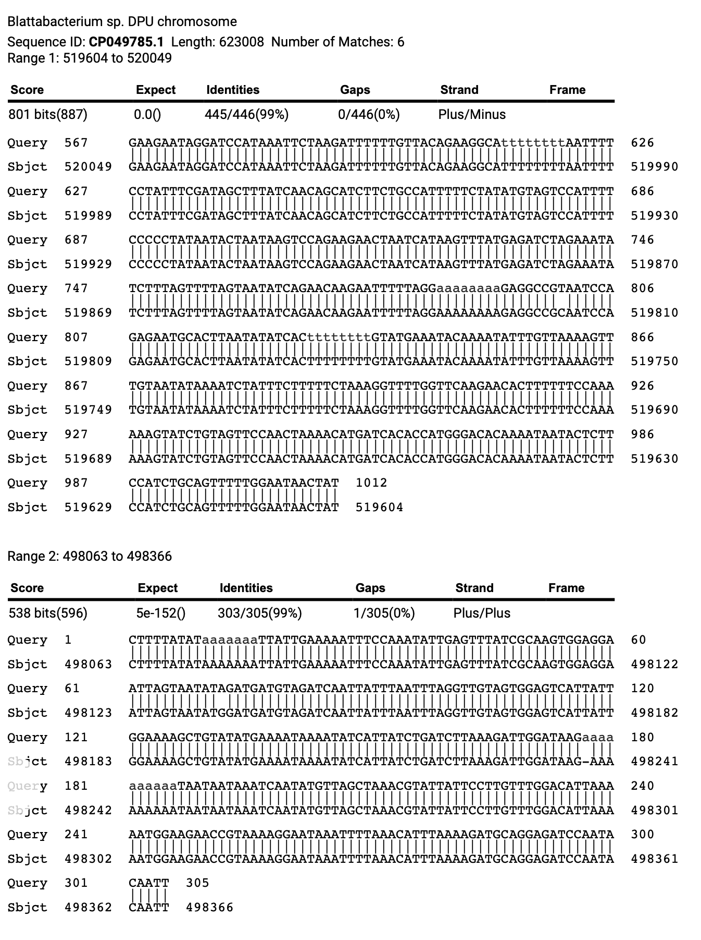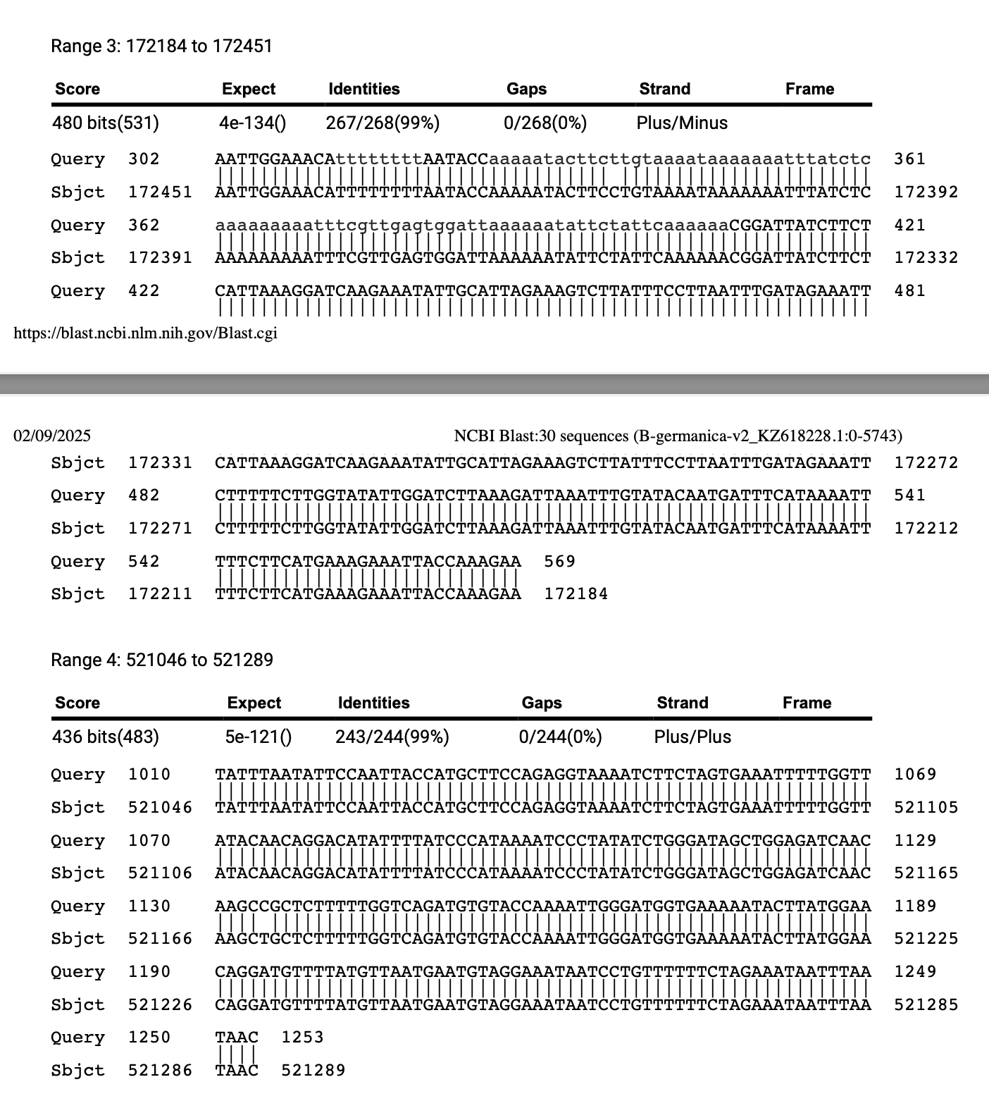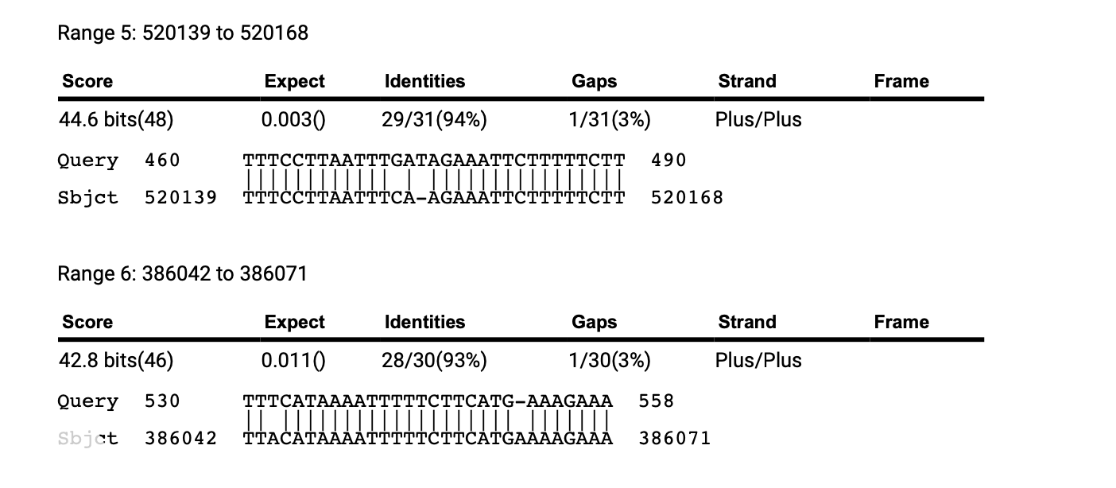

Additional chimeric sequence 2:
Neogeoscapheus dahmsi contig_7972: 1051443-1052600 (1157 bp)
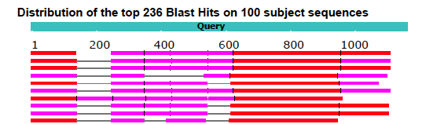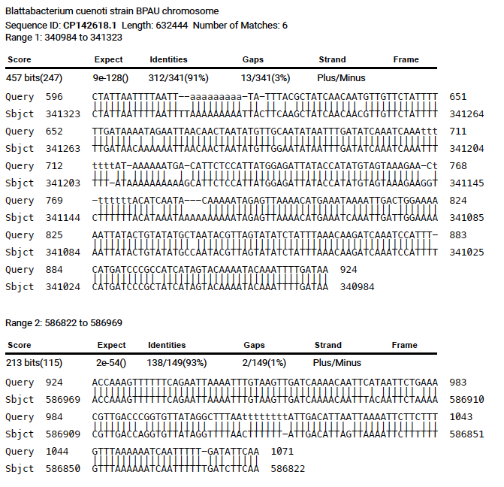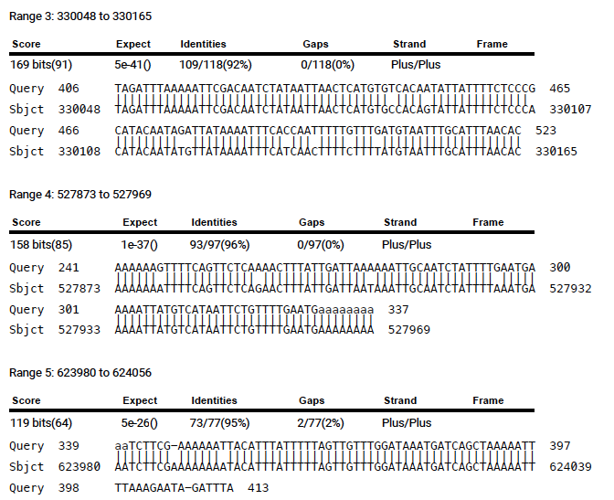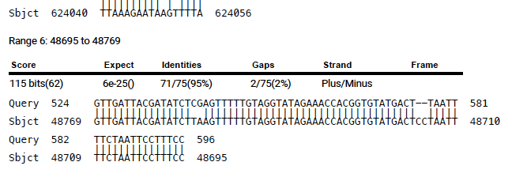

Additional chimeric sequence 3:
Panesthia cribrata ctg. 000829F: 236708-238036 (1328 bp)
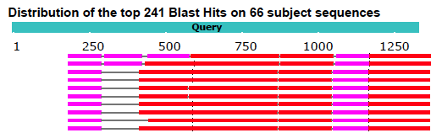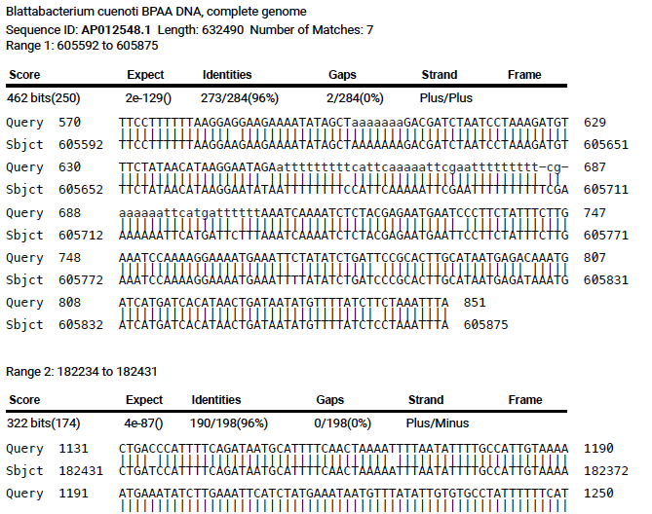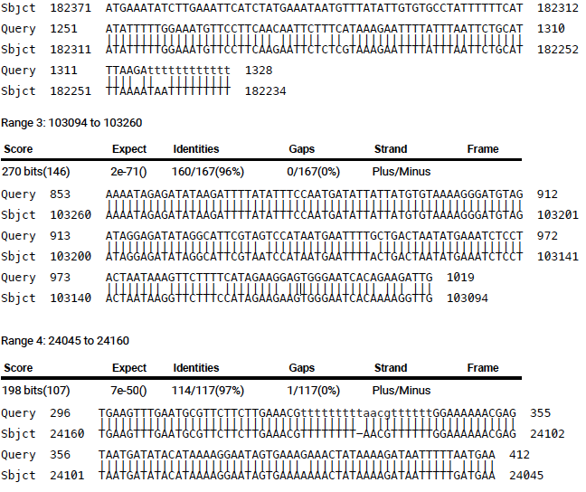
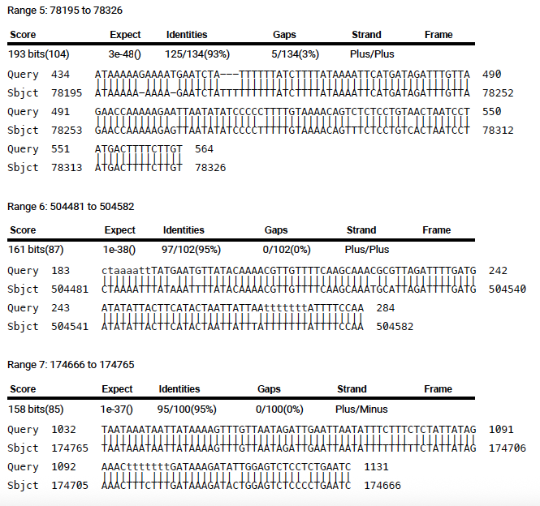

Additional chimeric sequence 4:
Parapanesthia gigantea contig_13648: 515186-516859 (1673 bp)
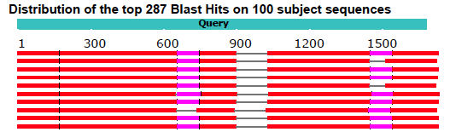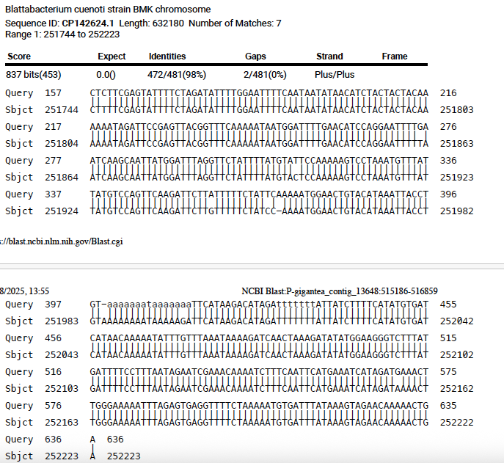
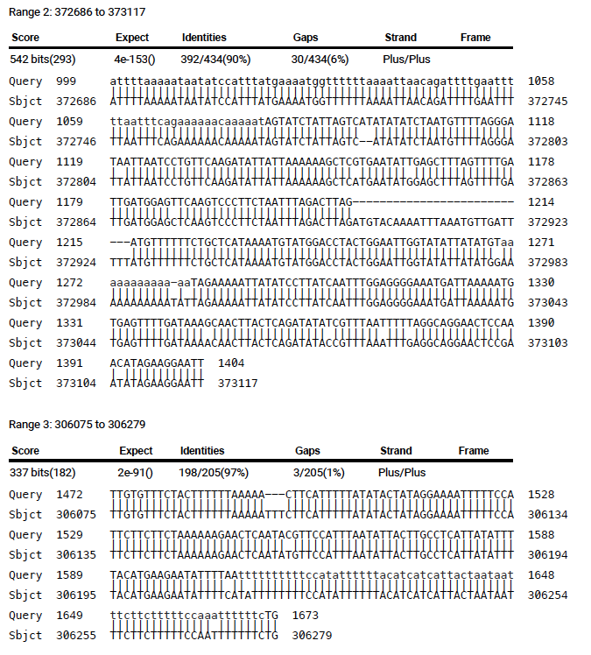

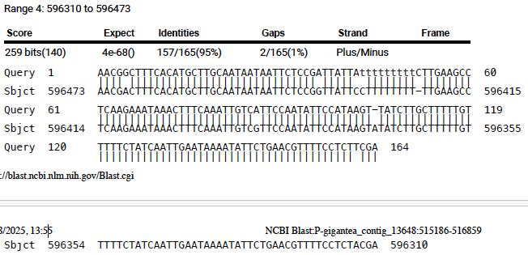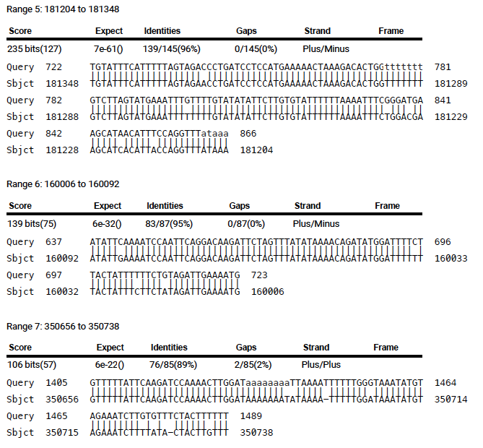

Additional chimeric sequence 5:
Panesthia lata contig_1558: 4419266-4421106 (1840 bp) 